1.
Preheat the oven to 220°C/ 200°C (fan)/ gas 7
Trim the green stalks off aubergine[s] and cut into quarters lengthways, then chop into big pieces
Rub the chopped aubergine with a drizzle of olive oil and the ground cumin, then season with salt
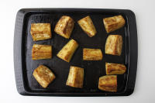
2.
Heat a large, wide-based pan (preferably non-stick) with a drizzle of olive oil over a high heat
Once hot, add the seasoned aubergine and cook for 1 min each side or until browned
Transfer the browned aubergine to a baking tray and put it in the oven for 20-25 min or until cooked through (reserve the pan for later!) – this is your spiced aubergine
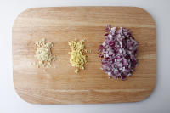
3.
While the aubergine is cooking, boil a kettle
Peel and finely chop (or grate) the garlic
Peel (scrape the skin off with a teaspoon) and finely chop (or grate) the ginger
Peel and dice the red onion[s]

4.
Return the pan to a medium heat with a drizzle of olive oil
Once hot, add the diced red onion with a pinch of salt
Cook for 5 min or until softened
Add the chopped ginger, chopped garlic and the curry powder and cook for a further 3 min
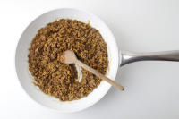
5.
Rinse the red lentils in a sieve under the cold tap
Add the red lentils and canned green lentils (no need to drain) to the softened onion
Dissolve the vegetable stock mix in 350ml [550ml] boiled water
Add the vegetable stock to the lentils and cook for 10-15 min, stirring occasionally, until all the water is absorbed and the lentils are tender and porridge-like in consistency
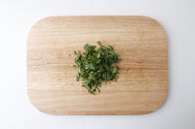
6.
Meanwhile, chop the coriander finely, including the stalks
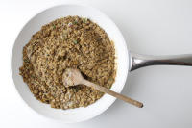
7.
Once the lentils are cooked, remove them from the heat and stir in 2/3 of the coconut yoghurt, 2/3 of the chopped coriander (save the rest for garnish!) and a grind of pepper – this is your two-lentil dal
Taste for seasoning, adding more salt and pepper if needed
Serve the two-lentil dal in bowls topped with the spiced aubergine
Garnish with the remaining chopped coriander and a dollop of the remaining coconut yoghurt
Enjoy!

